**Assignment – 2**

**Linux Commands**

1. Create user with name Techie and provide sudo access to user

* Created user name – useradd Techie
* Provide sudo access and password to user

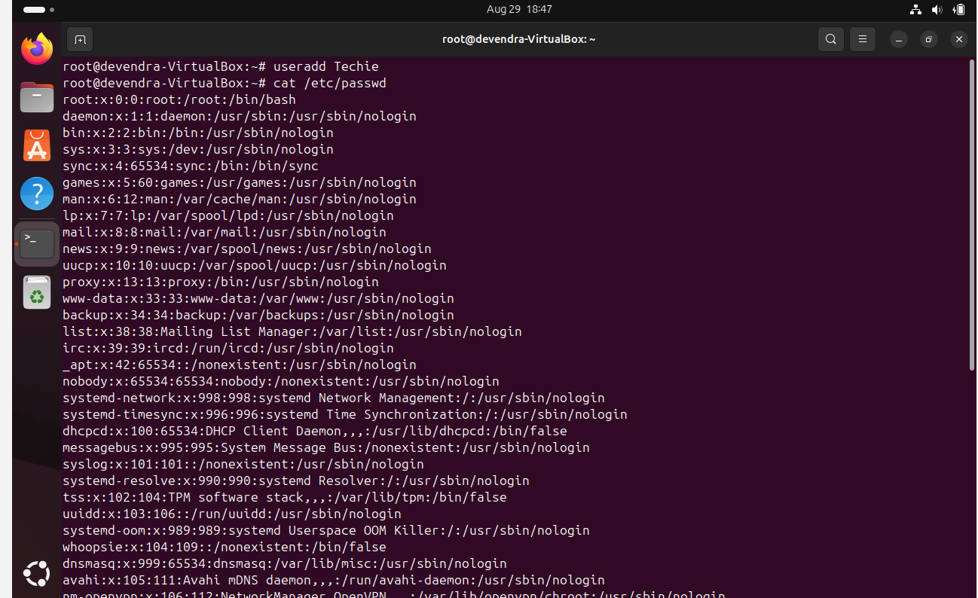

* **Cat /etc/passwd -** Find all the users in the system

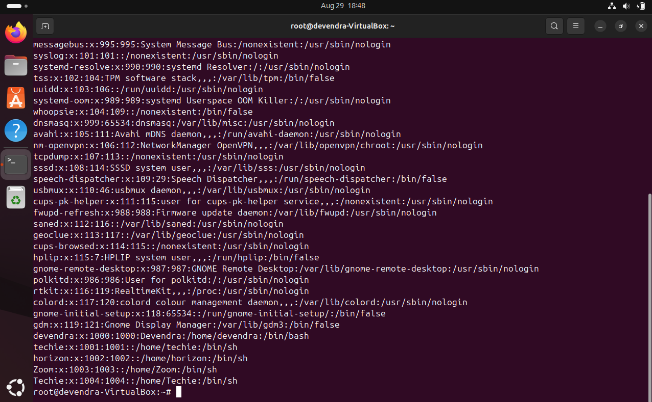

2)  Navigate to the home directory

* Here navigate to home directory (~) - **cd ~**



3)  Create a new directory

* By using mkdir command , created new directory (deva) – **mkdir deva**



4)  List the contents of a directory

* **ls -** It gives the list of files and directories



* ll – it gives long list and complete details of our file system

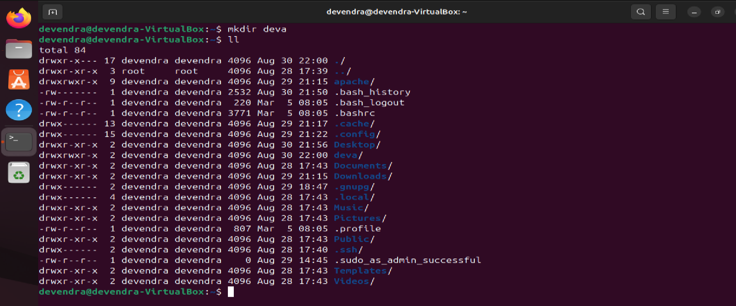

5) Change the current directory

* **cd** **Desktop/**- Change directory to desktop



6)  Create a new empty file

* **touch Hello** - Creates a zero byte file
* **ls** - it gives list of files



7)  View the contents of a file

* **cat Hello** - Read the contents of file
* **vi Hello** – To write the content in the file
* **:wq! -** To save the content



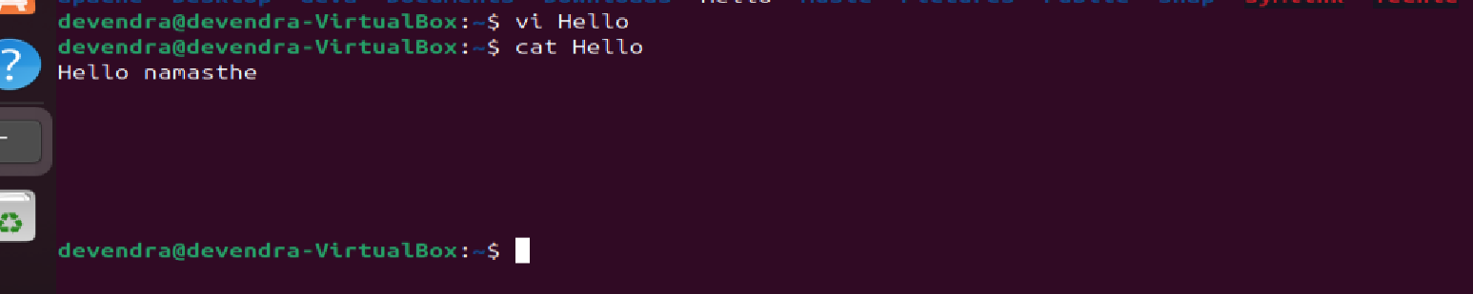

8)  Copy a file to another location

* **cp Hello Desktop -** copy file from hello to desktop



9)  Move a file to another location

* **mv techie deva**

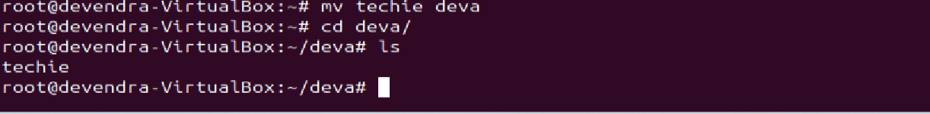

10) Rename a file

* **mv alphabet horizon** - Rename a file

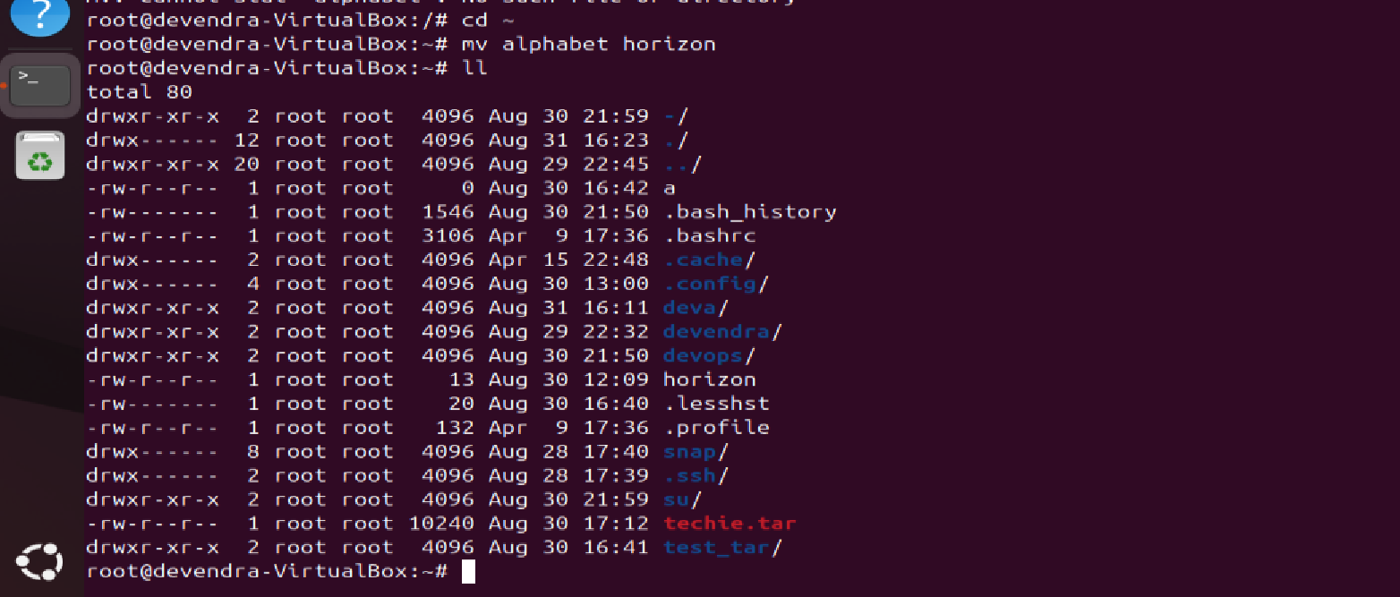

11) Delete a file

* **rm Hello** - Removes the file

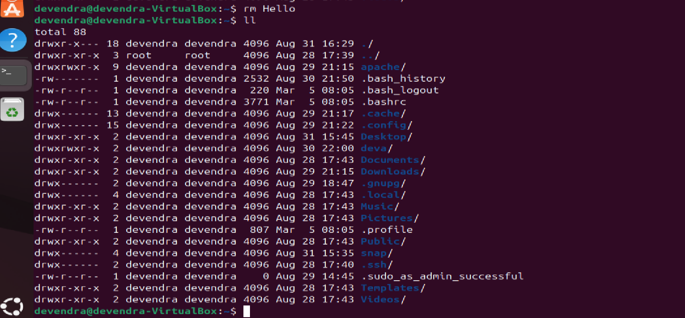

12) Grant or revoke permissions on a file or directory: chmod 777 snap

* chmod 777 snap –Given full access to snap

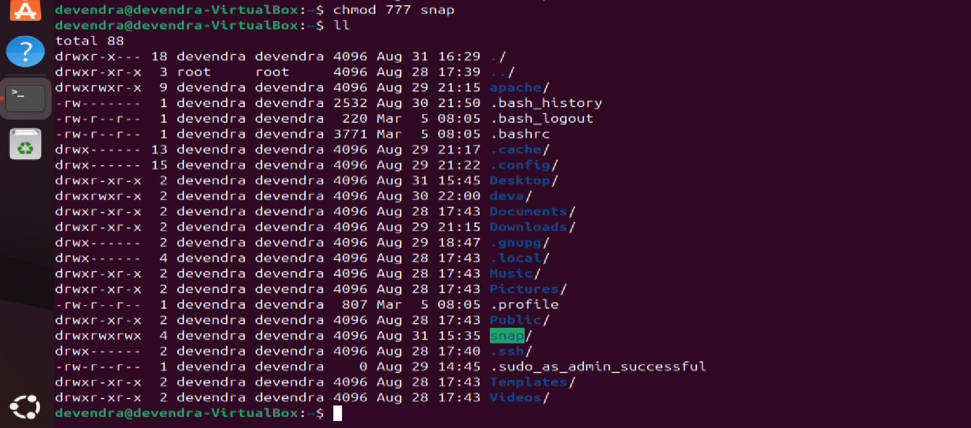

* chmod 000 snap – No access given

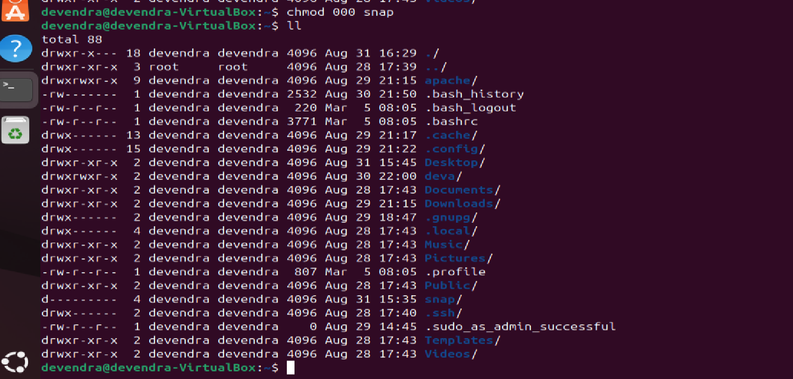

13) View the current date and time

* **date -** it gives date and time



14) Check the system uptime: uptime



15) View the running processes

* **ps –ef** - it shows running process

 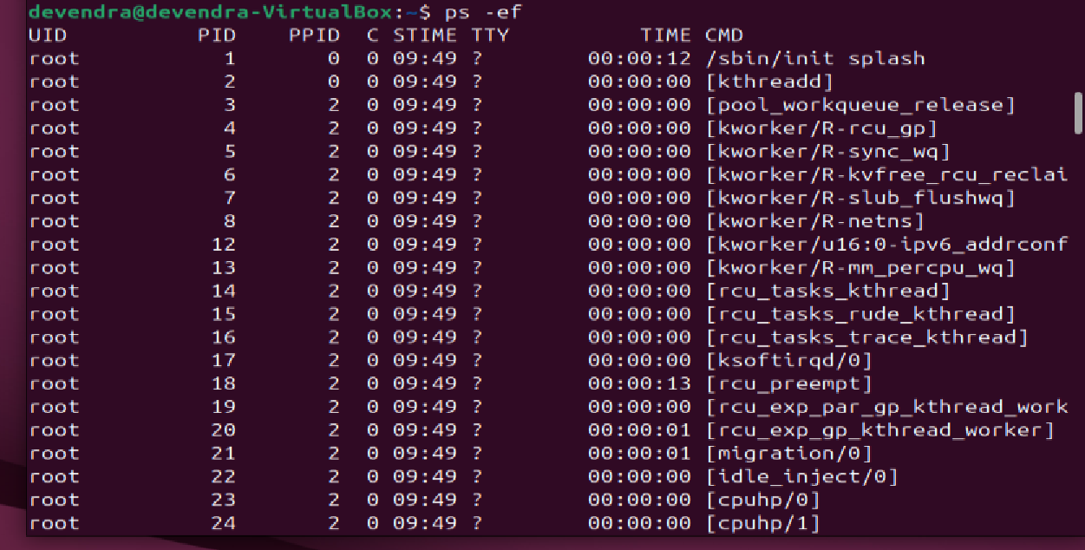

16) Kill a running process

* **kill -9 pid -** Forcefully terminate the process

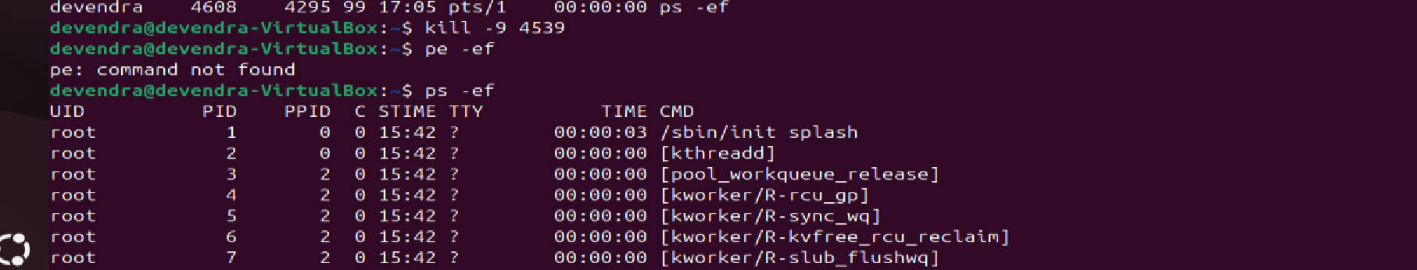

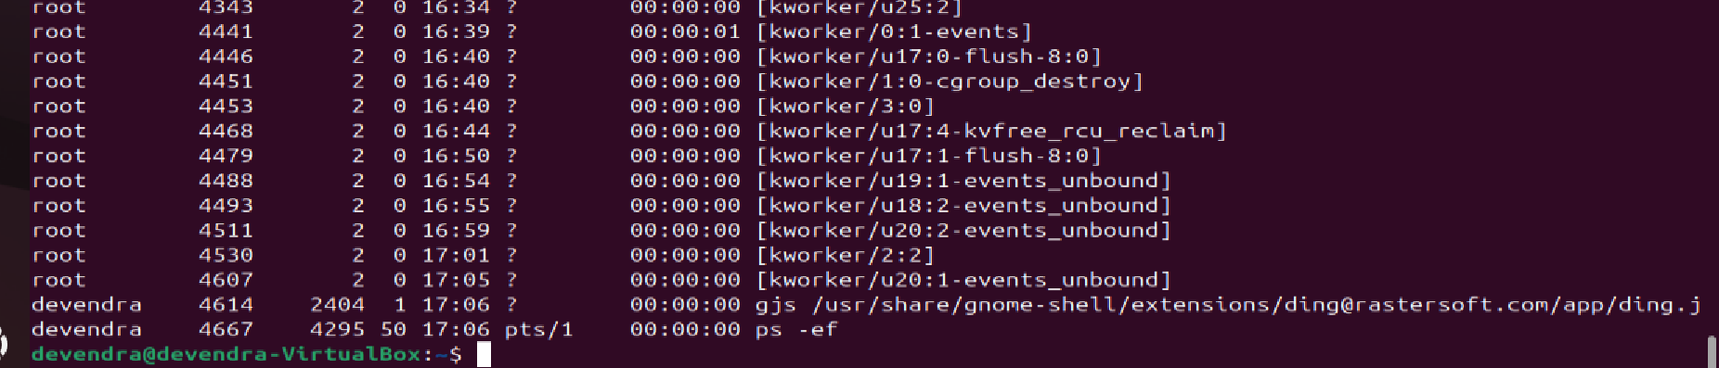

17) Install a package using the package manager

* **sudo apt install apache2 -** To install the package

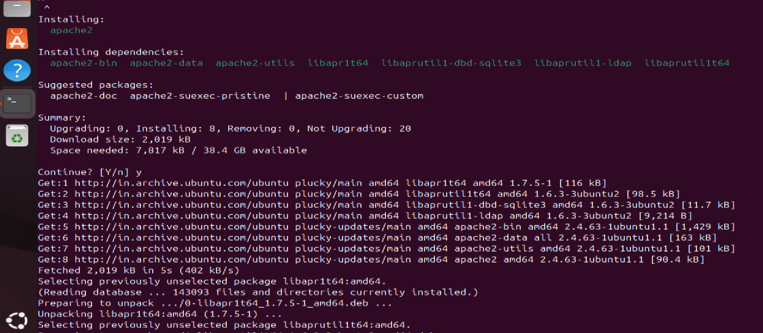

18) Update the system packages

* **sudo apt upgrade**



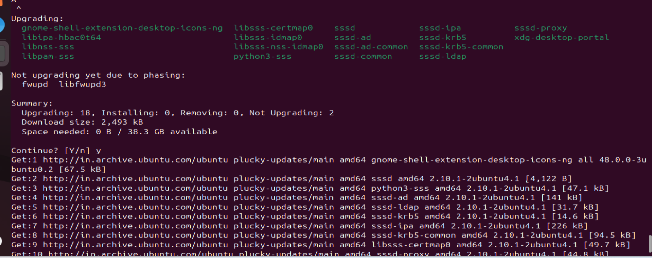

19) Create a symbolic link

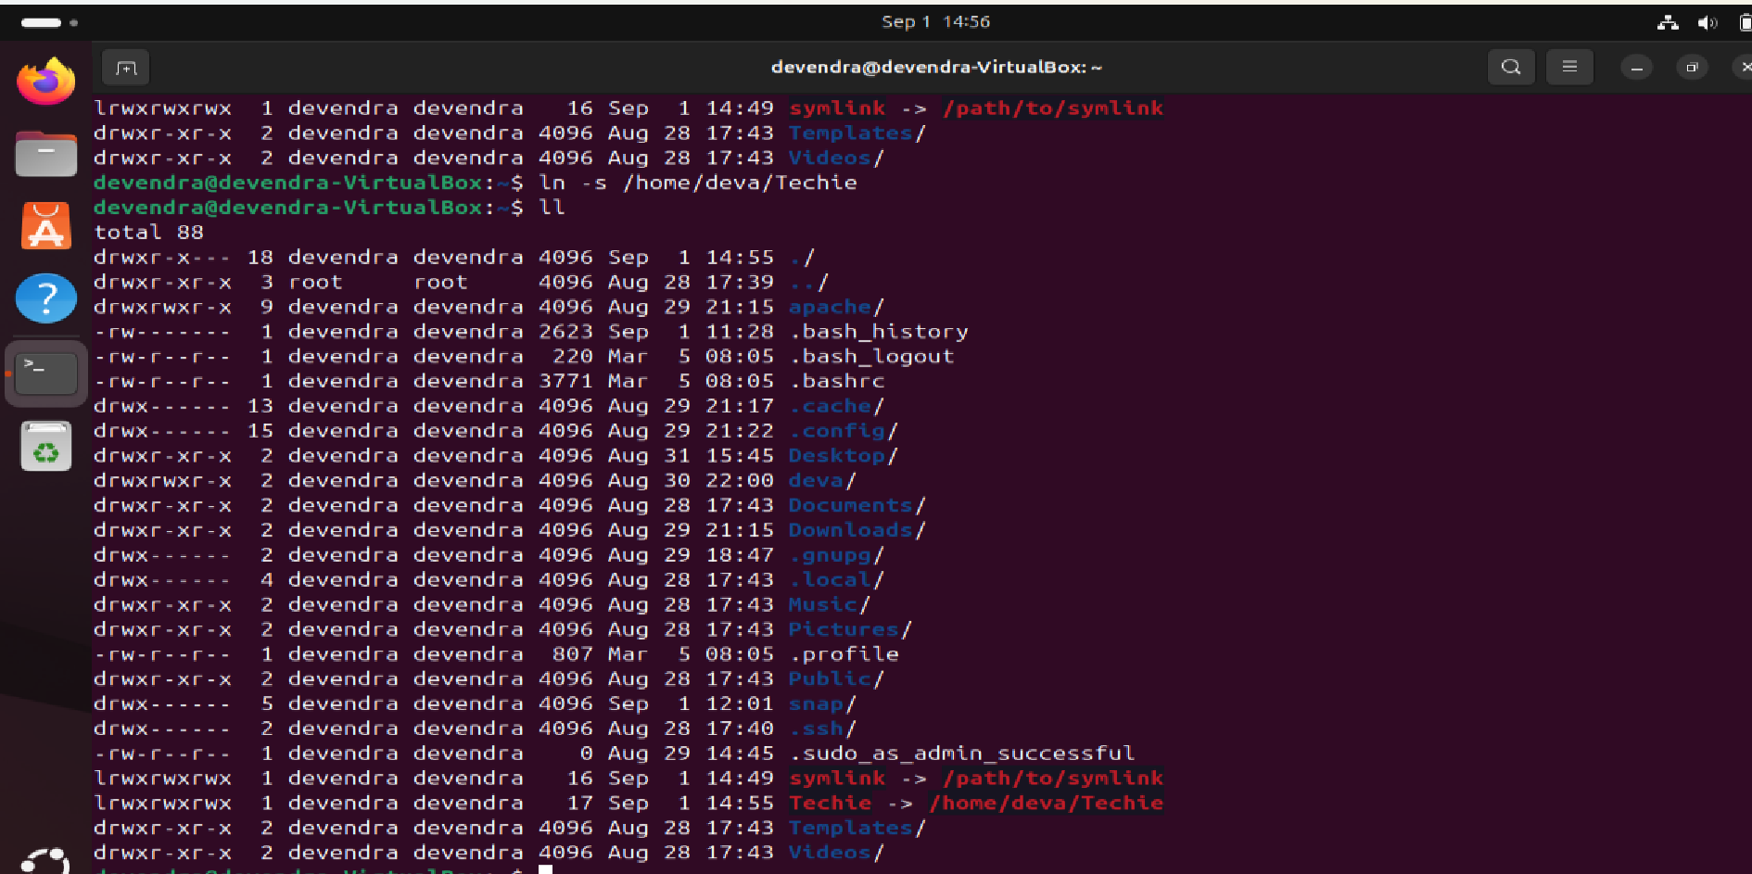

20) Search for files using the find command

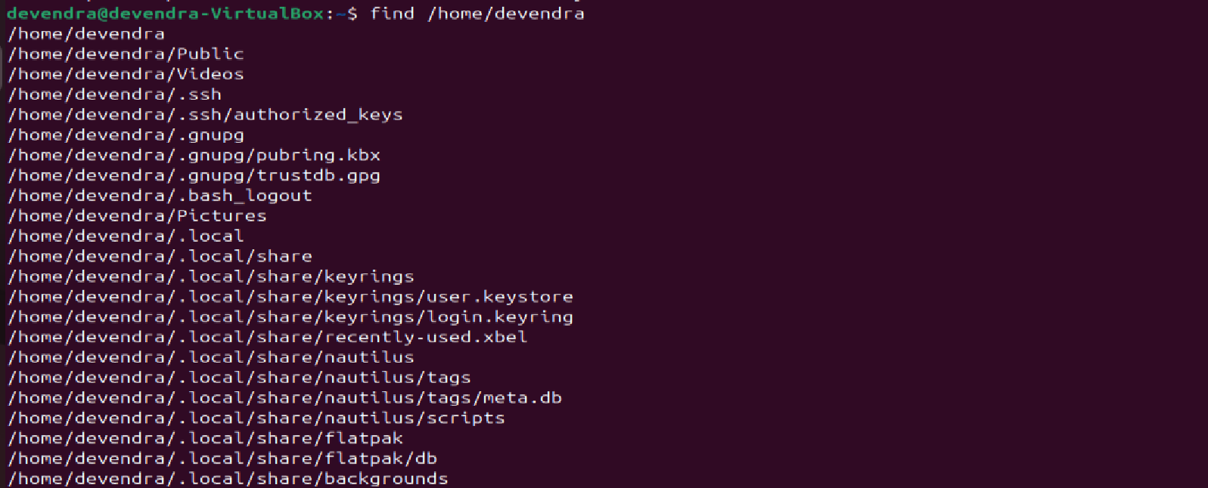

21) Compress and decompress files using tar

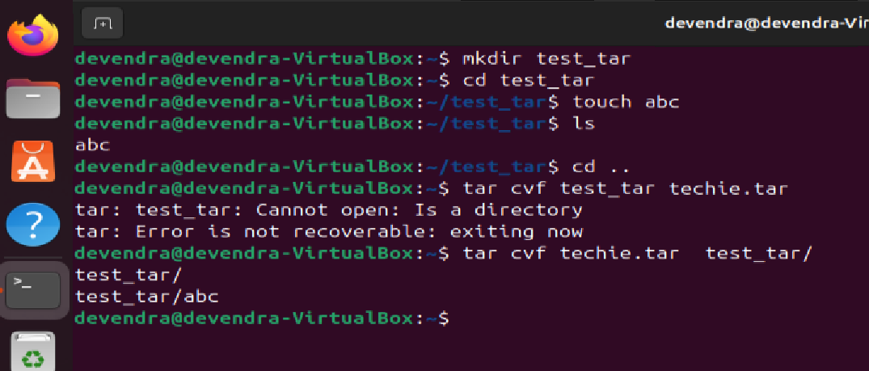

22) Monitor system resources with top or htop

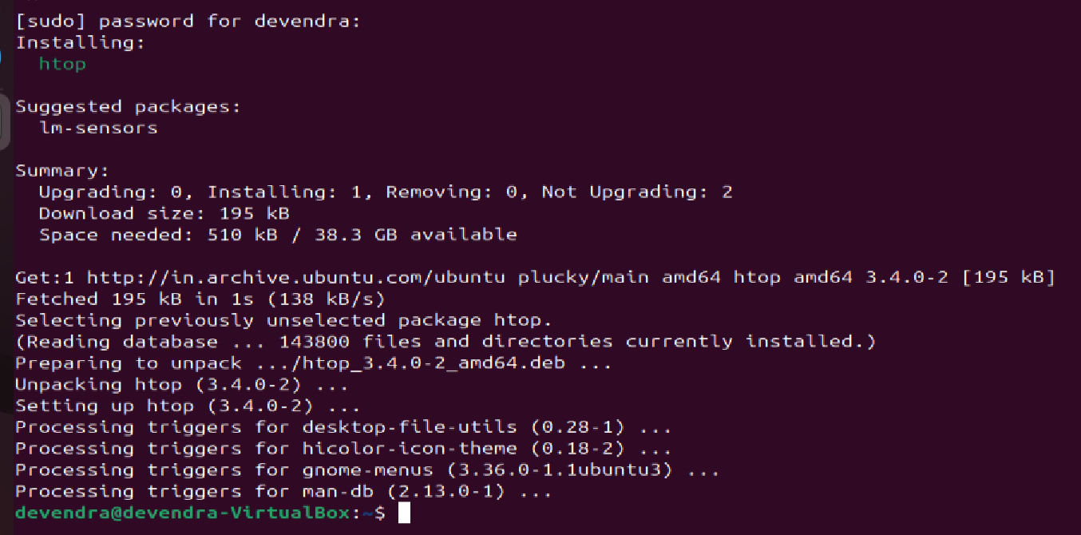

23) Create and manage user groups

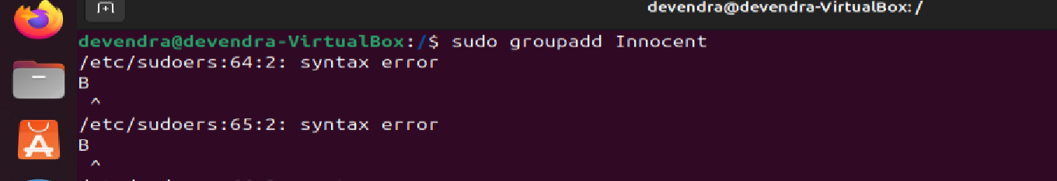

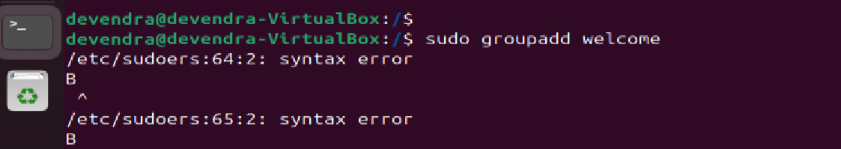

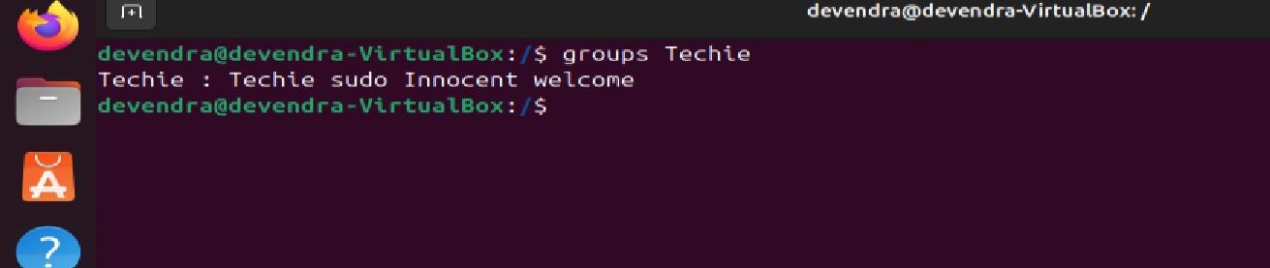

24) Set up SSH password less authentication

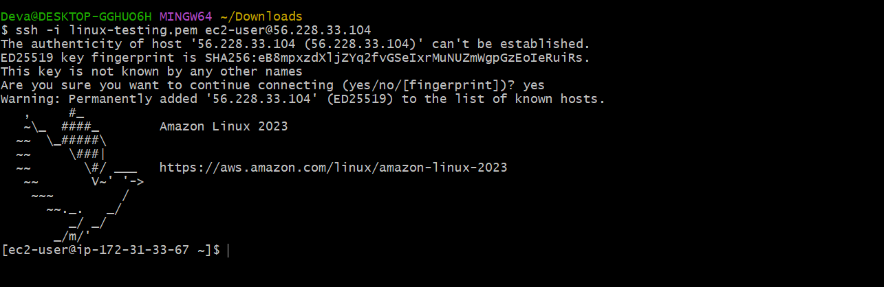

25) Monitor log files using tail or grep

* tail –f - it continuously monitor the file



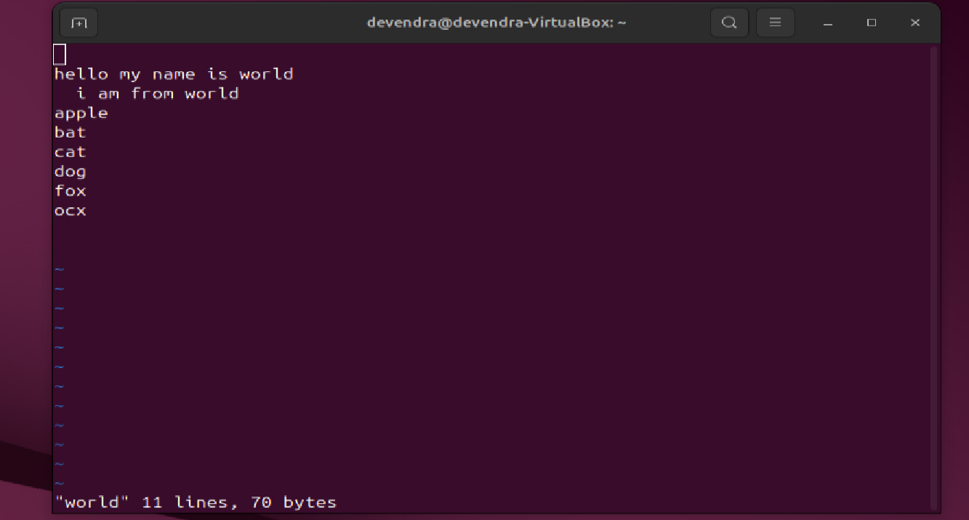



26) Set up a web server (e.g., Apache or Nginx)

* Installed apache2 and started

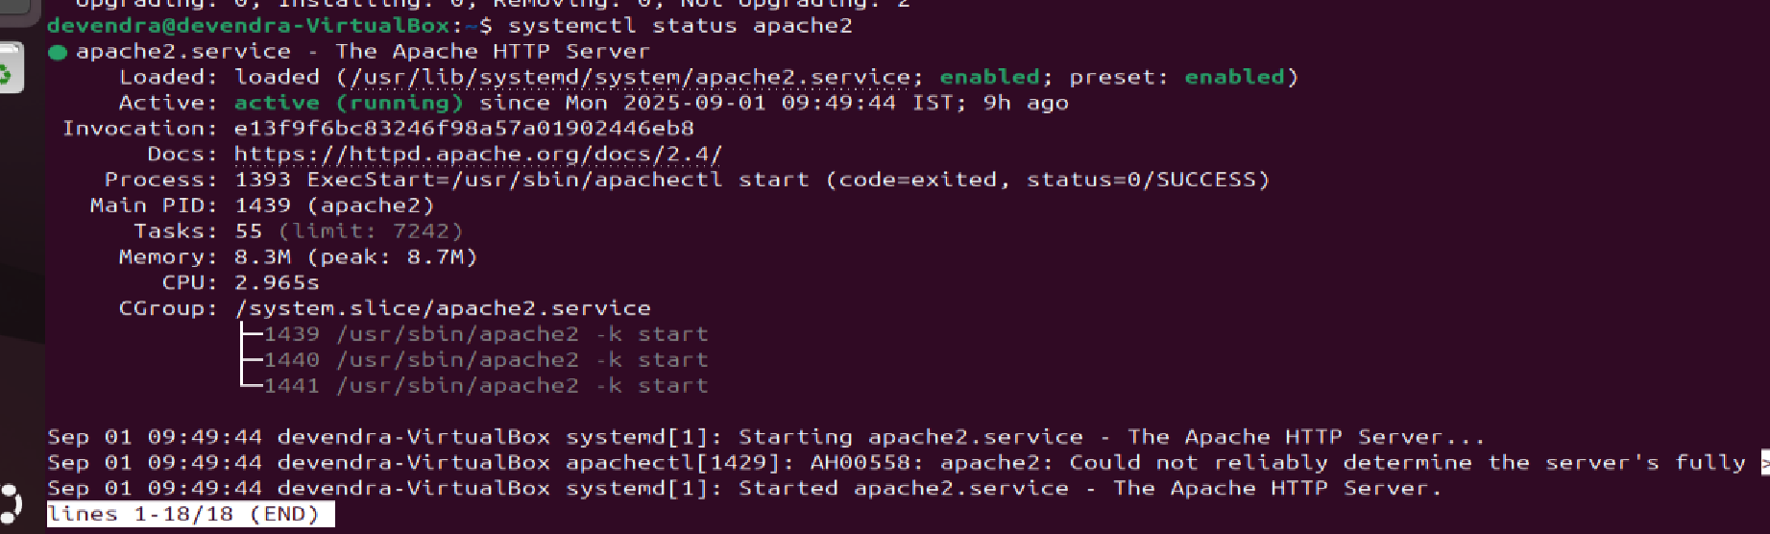

* Check the status : systemctl status apache2

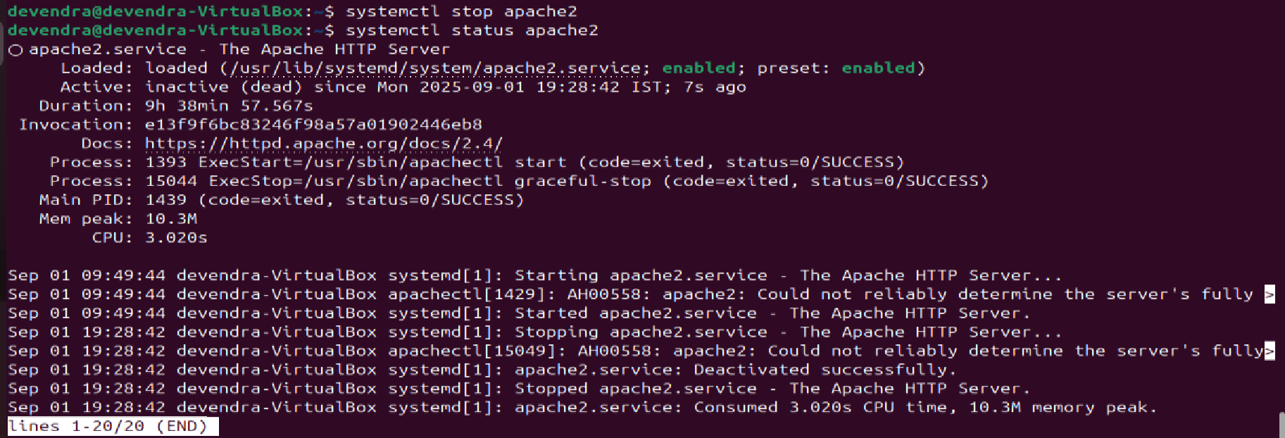

27) Configure and secure a MySQL Database

* Sudo apt installmysql-server



* Sudo mysql_secure_installation

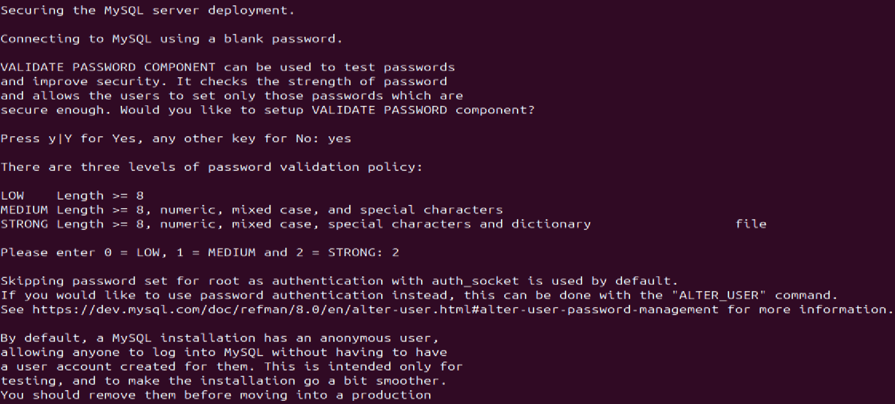

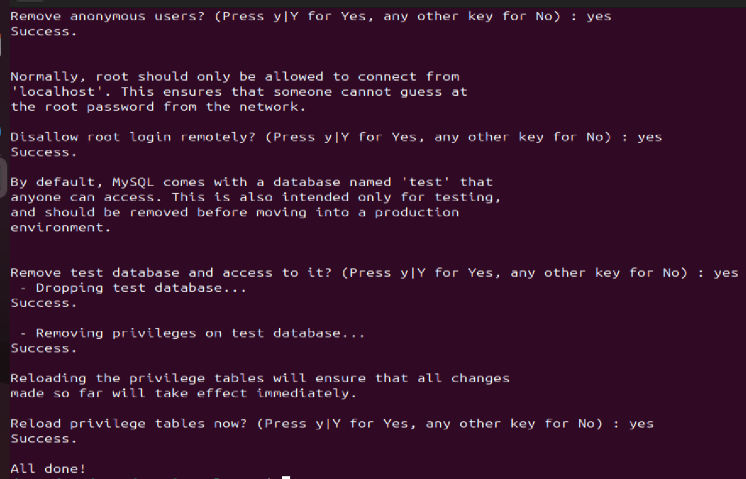

28) Set up a Application Server (e.g.,Apache Tomcat)

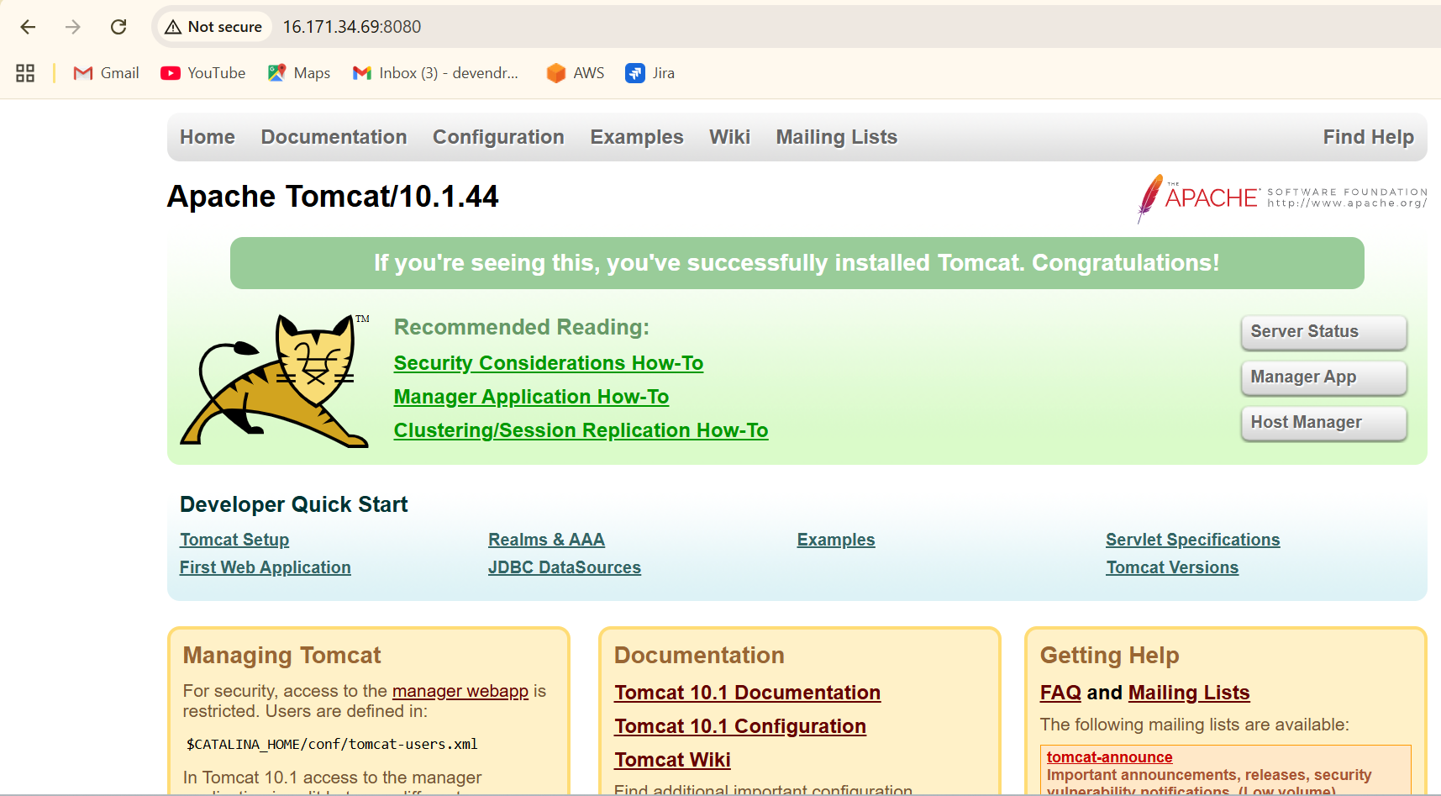

29) create a service file for Apache Tomcat.(Should execute by using systemtctl command)

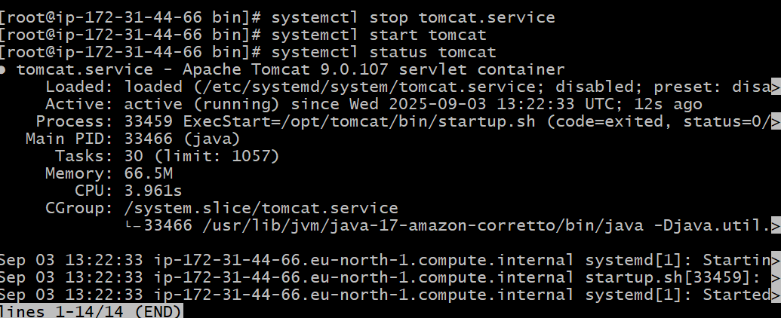

30) Print specific columns from a delimited file

* Use **awk ‘{print $m, $n}’ filename** command to print specific column

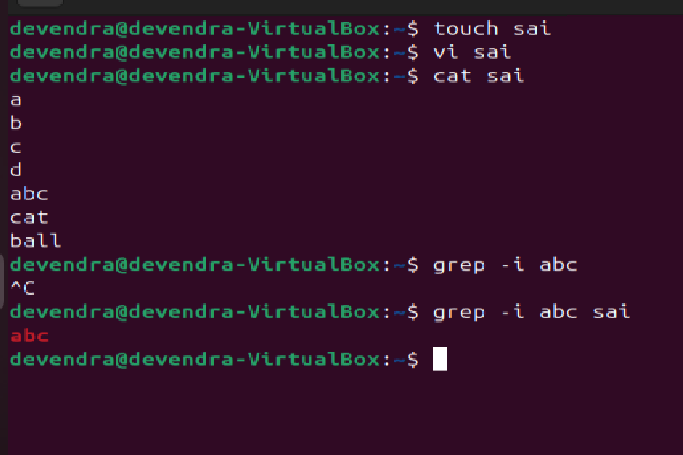

31) Filter and print lines based on a specific pattern or condition

* Use **grep “bug”filename** command to print.

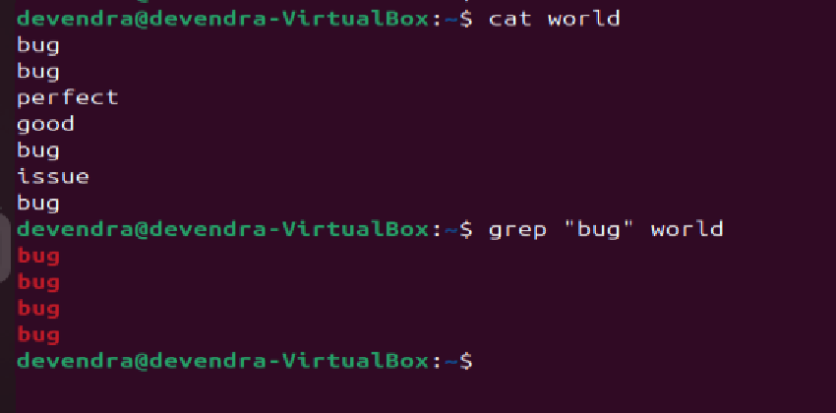

32) Calculate and print the average, sum, or other statistics of a column

* Use **awk ‘{sum += $3} END {print”sum =, sum}’ filename** command to calculate sum and use **awk ‘{sum += $3; count==} END {print “Average =”,sum/count}’filename** command for average

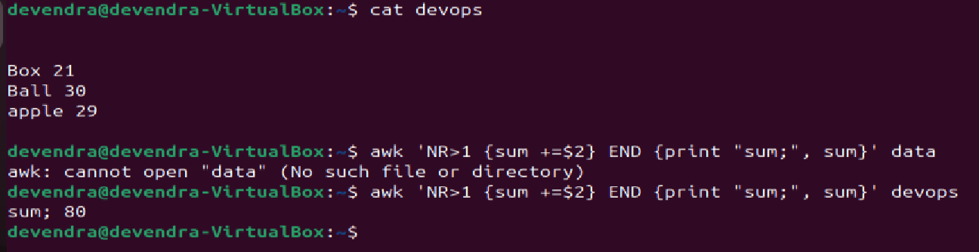

33) Perform string manipulation, such as extracting substrings or changing case

* Use **cut –c1-9 filename** - to extract substring

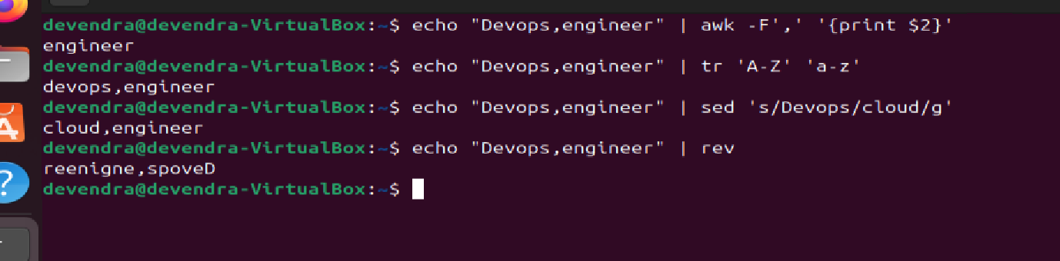

34) Count the occurrences of a specific pattern in a file

* Use **grep –c”pattern” filename** to count occurance.

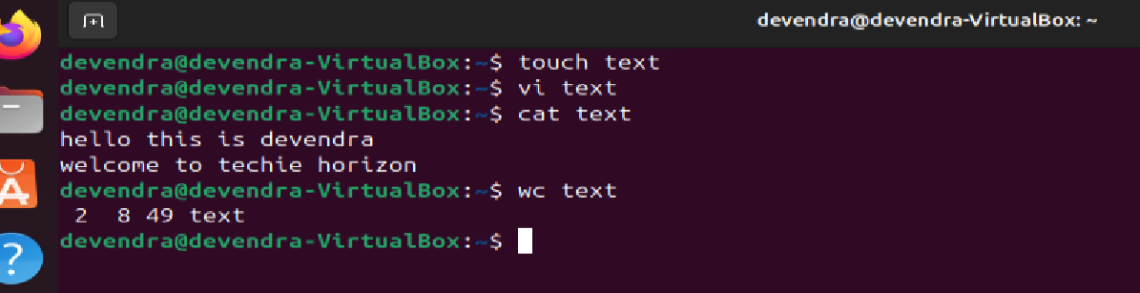

35) Sort lines based on a specific field or column

* Use **sort –k3,3n filename** to sort based on column

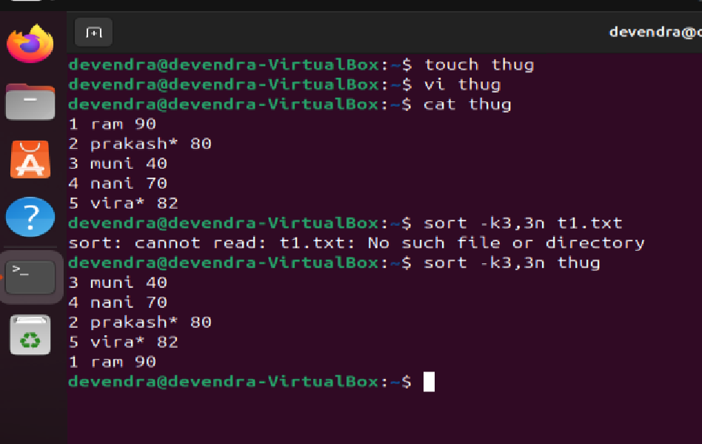

36) Merge multiple files based on a common field or column

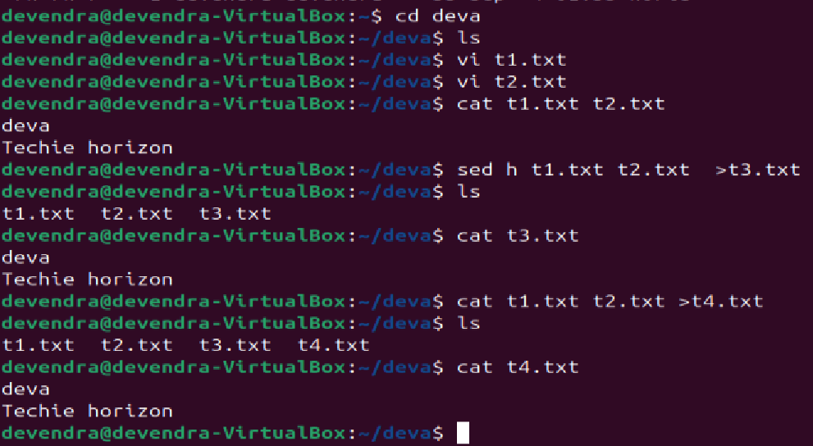

37) Substitute text in a file using search and replace

* Create one zero bytes file – **touch mv_file**
* write content in that file **vi mv_file**
* Use **sed’s/old/new/g’ file_name** to substitute text in a file.

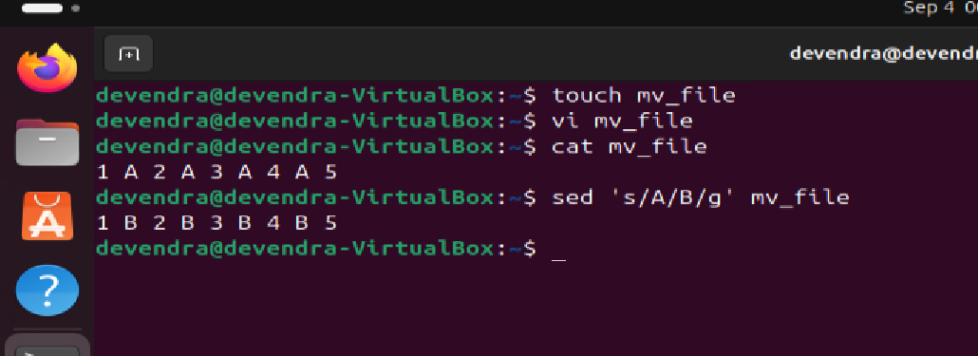  
38) Delete specific lines based on a pattern or line number

* Use **sed ‘m,nd’ filename** command to delete specific lines

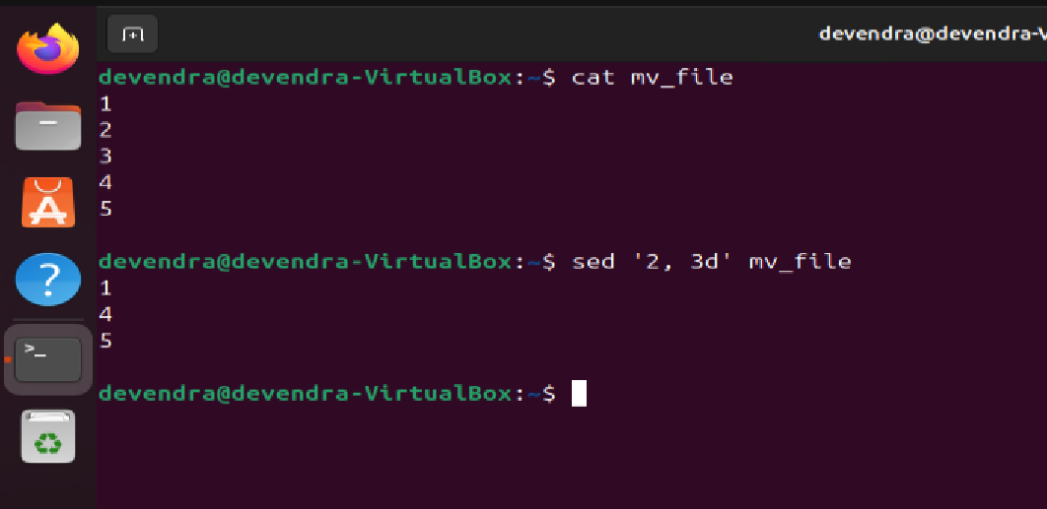  
39) Append or insert text before or after a specific pattern or line

* Use **sed ‘3i\inserted before line 3’ filename** command to print before a specific line.

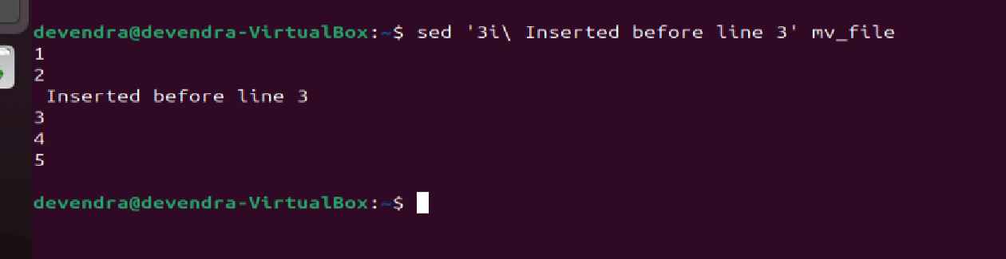  
40) Print only specific lines from a file

* Use **sed –n ‘N p’ filename** command to print only specific lines from a file.

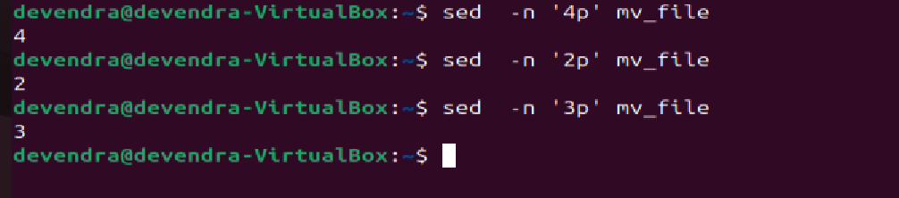

41)  Copy file from linux to windows machine

42)  5 use cases for AWK and 5 use cases for sed

* awk ’{print}’ filename – to print whole file

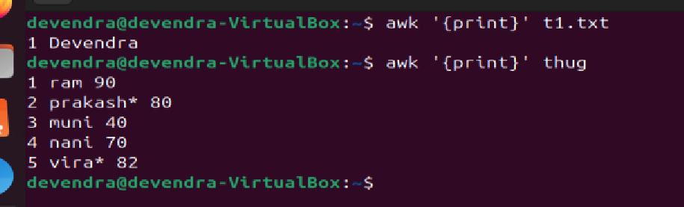

* awk ‘{print $1, $3}’ filename - to print specific column

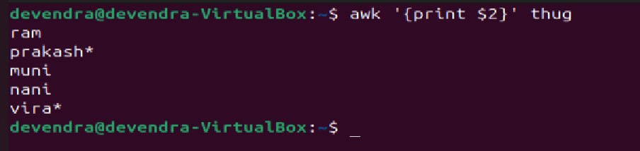

* awk ‘/pattern/ {print}’ filename - to print specific pattern

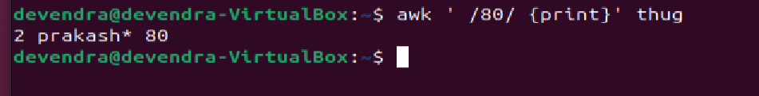

* awk ‘{sum += $2} END{print “Total sum:”, sum}’ data

to do arthematic operators

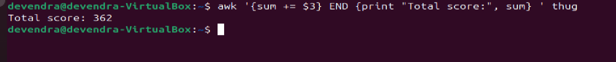

* awk ‘$4 > 50 {print $1, $2, $3}’ filename for condition

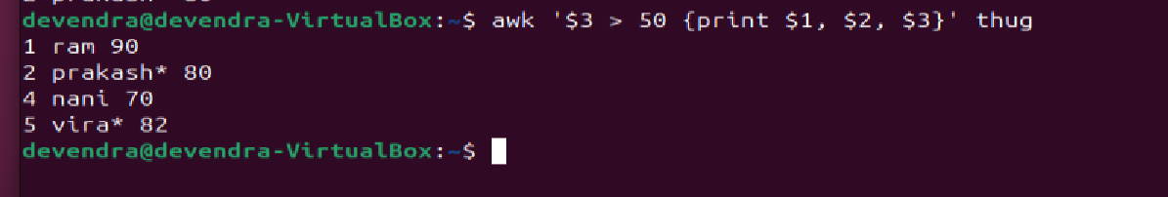

* **sed**
* **sed ‘nd’ filename** – to delete a specific line

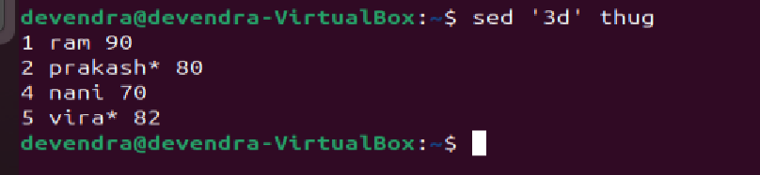

* **sed ‘m, nd’ file name** - to delete a range of lines

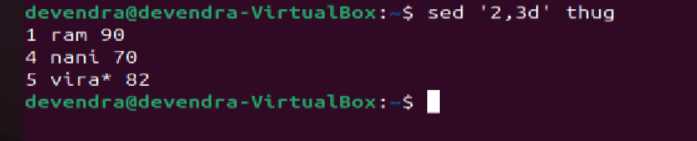

* **sed ‘/pattern/d’ filename** - to delete lines folling pattern



* **sed –n ‘3p’ filename** - to print a specific line



* **sed ‘ni\ line’ filename** - to add data before a line

